The Lincs AutoCoupler
The Lincs Autocoupler was originally developed by Dick Tarpey for use on the East Meon EM gauge layout. They were later offered for general sale to other modellers and enjoyed popularity with many users in both 4mm and 7mm scales, but they were unavailable for some years until I took over the manufacture, sales and marketing of the kits.
The couplers use a steel wire hooked armature fixed to a pivoting tube. Coupling is effected by pushing the wagons together; the two hooks meet and depress the armatures, the hooks pass each other and the armatures rise. Uncoupling is achieved automatically over a magnet placed between the rails and under the sleepers. If there is no tension on the hooks (i.e. the wagons are not being pulled) the armatures are pulled downwards and sideways by the magnet and the hooks are allowed to pass each other when one wagon is pulled away. (See photographs below). On moving away from the magnet, the couplers return to their normal position by the force of gravity, ready for coupling to another vehicle. They are supplied as a kit of parts, which are assembled with the aid of an assembly jig to ensure consistent operation.
Some advantages of the Lincs AutoCoupler are as follows:
- They are unobtrusive, the main visible component being a bent steel wire.
- They are offset from the wagon, coach, or locomotive centreline, so that 3-link and screw couplings can be retained on stock fitted with the couplers.
- Uncoupling is effected using hidden magnets buried under the track.
- They will couple and uncouple on curves if required.
- Wagons can be lifted upwards from the middle of a rake without the problem of couplings becoming entwined.
- The couplings, being made of steel wire, are hard-wearing, more robust than other wire-based couplers and less sensitive to misalignment and minor damage, especially during exhibition or intensive use.
For locomotives or rolling stock where it is difficult to fit a moving coupler, a fixed hook can be used, provided that it will always be coupled to a standard, pivoting coupler.
When I took over the production and sale of the Lincs AutoCoupler kits, stocks of some of the components, in particular the coupler base bracket and assembly jig etchings, were low and the artwork and tools had “gone missing”, I needed to recreate these before sales could begin again. New artwork and etchings are now available and I have produced improved instructions, based on my own experiences with the Lincs AutoCoupler. Production of the kits in both 4mm and 7mm scales has restarted and they are available for purchase from the address overleaf.
Prices are as follows:
LC4 - 4mm kit and LC7 - 7mm kit (each makes 5 pairs of couplers) £6.00 each
LCA - Assembly Jig (Only 1 is required as it is re-used for each coupler) £3.50 each
Postage: order value up to £30.00, p&p £1.50; over £30.00, p&p £2.50.
Payment is accepted by cheque, postal order, or PayPal. Order forms are available online from the email address overleaf.

For further details, please contact:
Richard Syms, 43 Highlands Crescent, Kinson, BOURNEMOUTH, BH10 5JR.
Email: richard_syms@btinternet.com
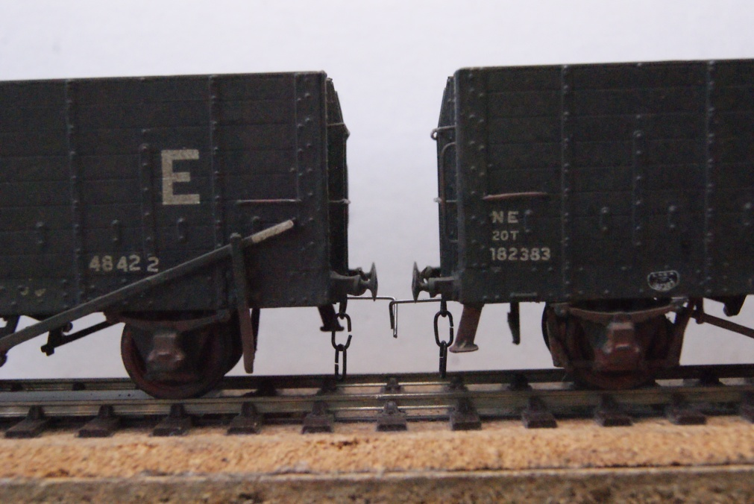
Couplers engaged

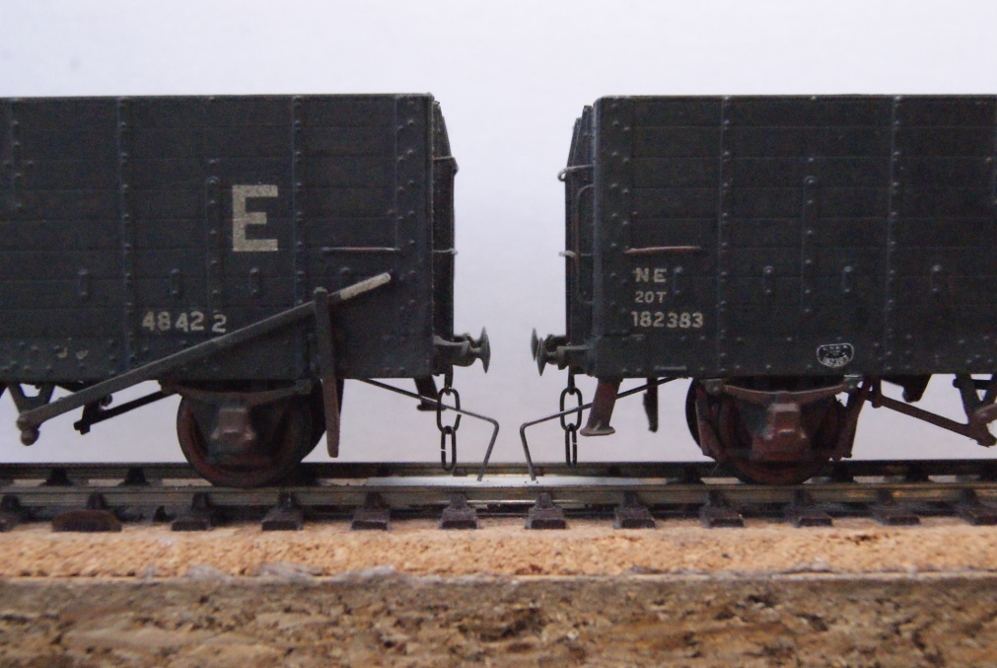
Couplers uncoupled over magnet below the track

